# Empowering the Nation - Logo

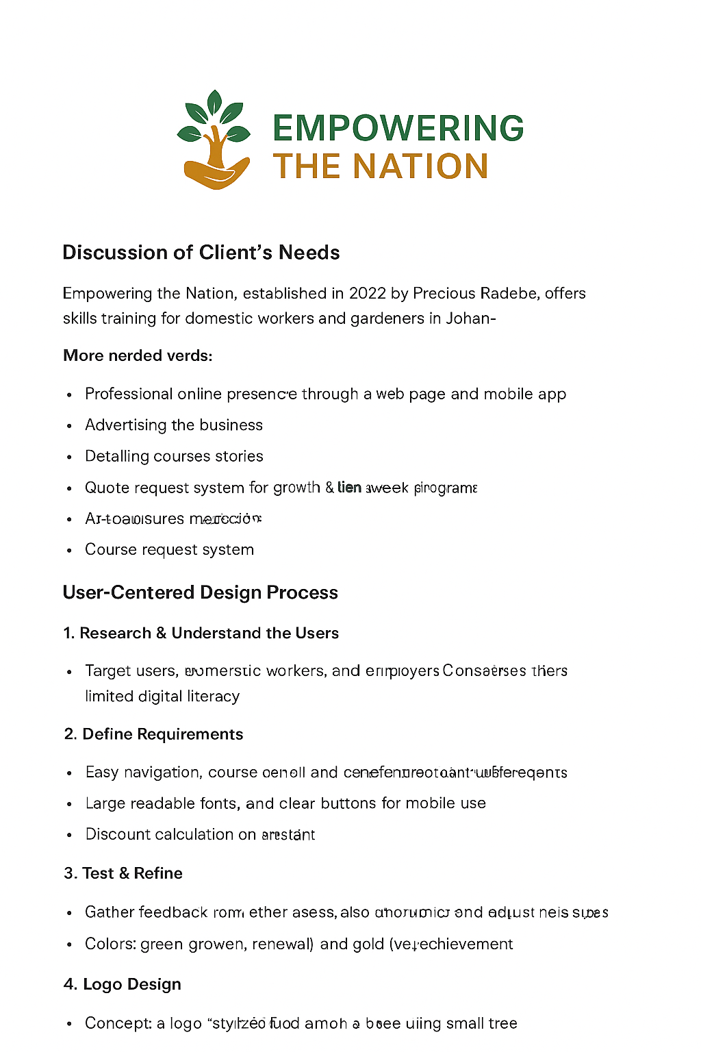

Concept: A stylized hand holding a small tree, symbolizing growth and support. Green represents renewal and development, while gold represents achievement and value. The logo is clean and uncluttered to ensure clarity on both mobile and desktop platforms.